5 Healthy New Year’s Resolutions

Upcoming Learning Opportunities

The 2020 Dietary Guidelines for Americans – New Revisions and Uses
Date: January 27
Time: 11:00 am ET
RSVP: https://militaryfamilieslearningnetwork.org/event/79976/

Food and Nutrition Before, During and After Disasters
Date: February 24
Time: 11:00 am ET
RSVP: https://militaryfamilieslearningnetwork.org/event/85668/

MILITARY FAMILIES LEARNING NETWORK
Nutrition and Wellness Newsletter
2021 Quarter 1
By: Haley Singer
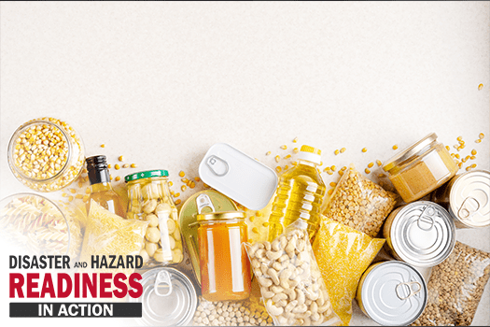
The New Year is a wonderful time to practice reflection and goal setting. If you choose to look at the year ahead as a blank canvas, you may find that this brings you a sense of motivation to paint it just the way you’d like.
First and foremost, you should focus on your personal health! Your well-being affects everyone around you, and it can even affect the things you attract into your life. I encourage you to take some time in 2021 and reflect on how you can raise your vibration and prosper in the New Year! And although most New Year’s resolutions are related to weight loss, yours do not have to be! You can still make goals that add healthy habits into your everyday life like the ones listed below:
- I will move my body for at least 30 minutes a day, five days a week.
- Each morning I will take 10 minutes to journal, reflect, or set an intention for my day.
- I will make it a priority to get at least 7 hours of sleep each night.
- I will cook at home for at least five meals per week.
- I will practice mindful eating by being present, enjoying my food, & listening to my body.
Food waste vs food safety: a balancing act
WHEN: March 23 at 11:00 am ET
Join us for this webinar to learn about the problem of food waste and how we as consumers can safely reduce the amount of food waste in our homes. 1.0 CPEU for Registered Dietitians. For more information and to register, visit the event page: https://militaryfamilieslearningnetwork.org/event/79969/
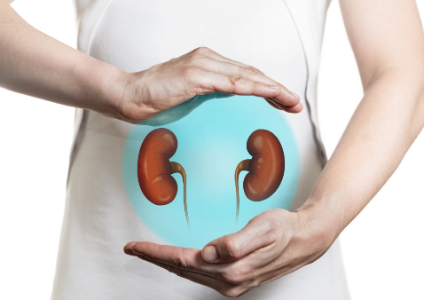
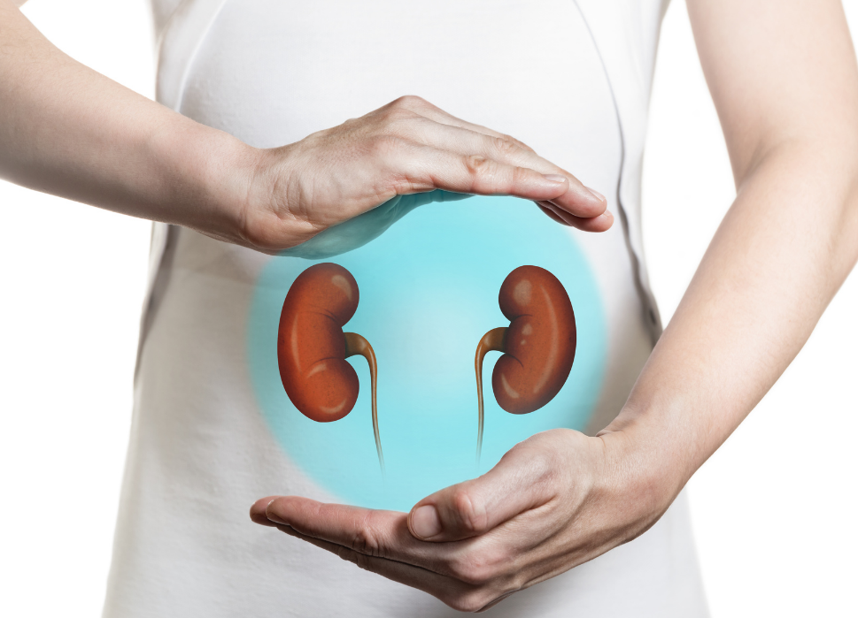

Kidneys,

TBI &

Nutrition

Month,

Oh my
By: Veronica Glatz
National Kidney Month: The kidneys are the organs that balance blood pressure and pH as well as removing waste from the blood and produce urine. Three ways to observe this holiday are to keep your kidneys healthy by eating a wholesome diet and exercising regularly. You can also donate to a kidney non-profit, and/or to join the organ donor registry.
National Traumatic Brain Injury Awareness Month: Traumatic brain injuries include concussions, car accident injuries, or any trauma to the skull. We can honor National TBI Month by encouraging helmet use and buckling seatbelts, promoting support for those with brain injuries, and empowering caregivers of brain injury patients.
National Nutrition Month: March also celebrates National Nutrition Month, which in 2021 supports healthier eating while personalizing one’s plate. National Nutrition Month also includes eating right on a budget, enjoying more fruits and vegetables, and snacking tips for kids.

American Heart Month
By: Madison Boissiere
February is American Heart Month, a time to raise awareness for the importance of heart health, the dangers of heart disease, and ways to reduce the risk of cardiovascular disease. Heart disease is the leading cause of death in both men and women, with about 655,000 Americans dying each month, meaning one in every 4 deaths is attributed to heart disease. These alarming statistics make it that much more important to take charge of your heart health now. Luckily, the risk of heart disease can be significantly reduced through a few key lifestyle changes.
Eating nutritious foods is a key part when it comes to heart health. Incorporate fruits, vegetables, nuts, whole grains, beans, and fatty fish into your diet while limiting the consumption of saturated fats, trans fats, added sugar, and sodium.
Aim to maintain a healthy weight. Research shows that the more body fat you have, the higher your chance is of developing heart disease and high blood pressure, among other serious health complications. You can start by going on daily walks, riding your bike, substituting in healthy foods, or even taking the stairs instead of the elevator at work.
Stop smoking. Smoking increases your risk of heart disease, heart attack, and many other health factors. Talk to a health professional about programs that can help you quit.
Get started on your journey to heart health now! Find more details at the American Heart Association’s website: heart.org.

Sleep and the RDN: Incorporating Sleep Ed to Reduce Chronic Disease Risk
- Last chance for CPEUs: March 18, 2021
- https://militaryfamilieslearningnetwork.org/event/56491/

Sunsetting CPEUs
Registered Dietitians are eligible for CPEUs for one year after the original webinar date.
Don’t miss out on free CPEUs from these webinars:

Exploring the Research on Fad Diets
- Last chance for CPEUs: February 12, 2021
- https://militaryfamilieslearningnetwork.org/event/52270/
Preoperative Nutrition Management of Bariatric Surgery Patients
- Last chance for CPEUs: January 15, 2021
- https://militaryfamilieslearningnetwork.org/event/52258/

This material is based upon work supported by the National Institute of Food and Agriculture, U.S. Department of Agriculture, and the Office of Military Family Readiness Policy, U.S. Department of Defense under Award Number 2015-48770-24368.

Winter 2021 quarter 1

